## Where we are headed: LP Implementation in PuLP/Python with Dictionaries and AMPLY

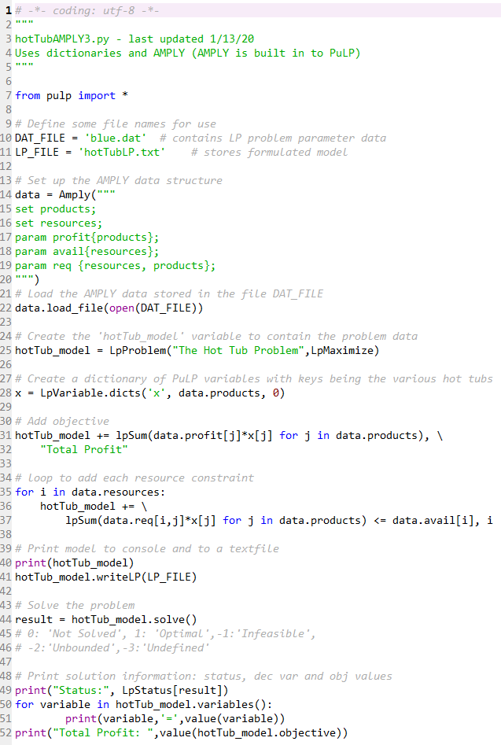

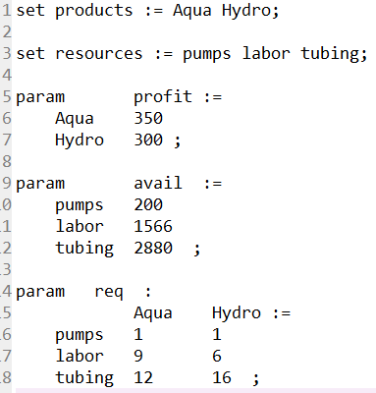

**blue.dat**